6A^{th} Grade: Unit 3, Lesson 4

- Identify the point values plotted on the number line.

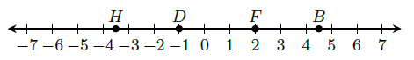

H = -3.5 D = -1 F = 2 B = 4.5

- Which of the values is greater: 4.75 or $\frac{19}{4}$? Explain.

Neither, the decimal form of $\frac{19}{4}$ is 4.75, which is the same value. They are equal.

- Which of the values is closest to 4: $\frac{3}{3}$ or -7.37? Explain.
$\frac{3}{3}$ is closest to 4 because $\frac{3}{3}$ simplifies to become 1 which is 3 away from 4 on a number line, while -7.37 is 11.37 away from 4 on a number line.

